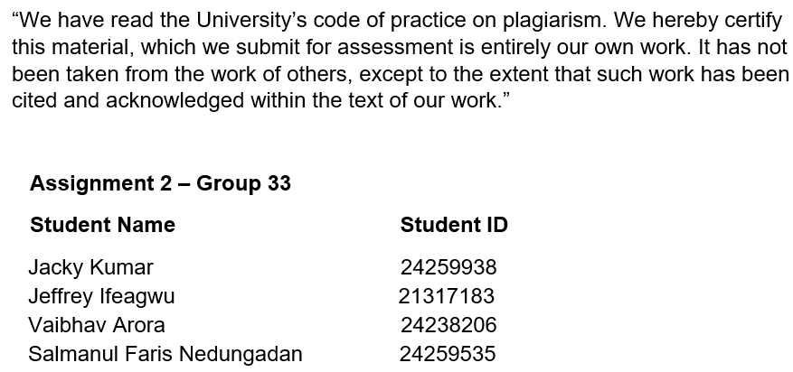

**Visual Story Presentation**

Adidas Sales Analysis

YouTube Video link: <https://www.youtube.com/watch?v=AFmv6KsuREc>

PowerBI Dashboard link: <https://app.powerbi.com/groups/me/reports/56bad242-46f7-4b97-a962-108b1ec974dc?ctid=13e3b186-c446-4aab-9c6d-9ab9bb76816c&pbi_source=linkShare>

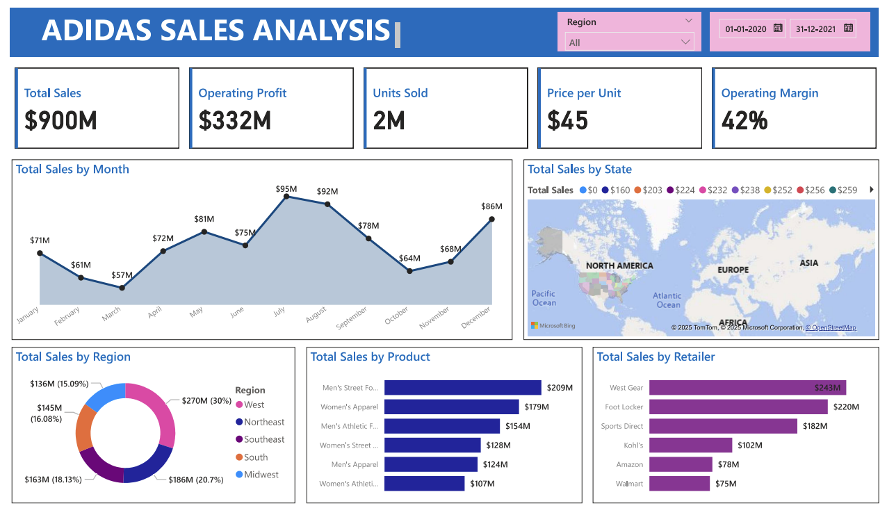

**Data Memo – Adidas Sales Performance**

The data say that ‘**Adidas’** strongest sales come from the West region of the United States, with peak performance during August and December. Certain product lines, like Men's Street Footwear and Women's Apparel, are driving this success, while underperformance in some regions and retailers’ signals room for growth.

We want to tell this story because it highlights how Adidas can leverage its strongholds while addressing weak points through regional strategy, seasonal promotions, and retailer engagement.

Our audience is Adidas sales and marketing leadership team, as well as regional retail partners involved in sales execution.

**Our goals are to:**

* Provide a clear picture of what’s driving sales success.
* Highlight gaps or inconsistencies that may be limiting further growth.
* Recommend actionable strategies to optimize performance by region, time, and product line.

**Key Insights:**

* West region contributes over 30% of total sales.
* August shows the highest monthly sales ($92M), followed by a dip and recovery in December.
* Men’s Street Footwear and Women’s Apparel lead in product revenue.
* West Gear outperforms other retail partners, suggesting strong synergy.

**Misleading Visual**

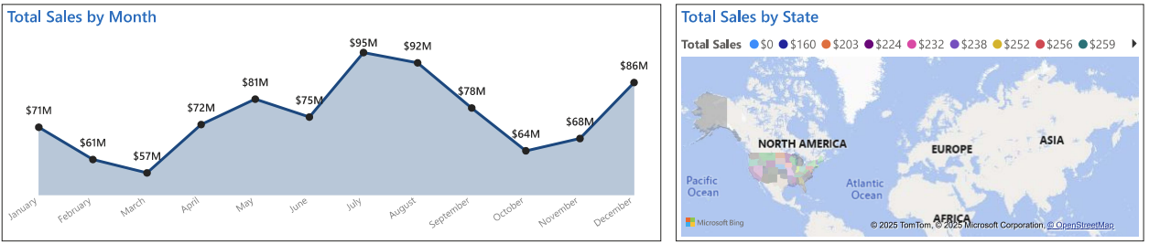

One visual in our dashboard — the Filled Map by State — was intentionally designed to be misleading. While it shows geographical sales distribution, it lacks clear state boundaries and uses vague colour intensities, making it hard to compare states accurately. A Shape Map would have provided better clarity and helped users interpret the data correctly. This inclusion emphasizes the importance of using the right visual tools to avoid miscommunication.

**Recommendations:**

* Invest more heavily in the West and Southeast regions where performance is strongest.
* Run targeted promotions in mid-year months (e.g., May–July) to close seasonal gaps.
* Expand successful retail models like West Gear’s approach to underperforming partners.
* Always apply clear and accurate visual design to ensure responsible data storytelling and decision-making.

**Conclusion:**

In conclusion, the Adidas sales data tells a compelling story of regional dominance, product strength, and seasonal opportunity. While performance in key areas like the West region and specific product categories is commendable, there are clear opportunities for growth through strategic regional focus, smarter promotional timing, and improved retailer partnerships. Moreover, this analysis reinforces the importance of using clear and ethical visualizations to support informed decision-making. By acting on these insights, Adidas can drive more consistent, profitable, and data-informed growth across all markets.